Experiment-9.a

Date-03-Oct-2018

**Aim:** To write a c++ program to get test and sports marks of student and print result using multiple inheritance .

**Algorithm:**

1: Start.

2: Define base class as student with variables name, branch and roll.

3: Define member function of class as get_data() and display1().

4: Define derived classes of student as test and sports with variables t_marks and s_marks.

5: Define member functions as get_test_marks(), display2() , get_sports_marks() and display3().

6: Define a derived class of test and sports class.

7: Define member functions of class result as get_info() , display().

8: Definition of main function.

9: Declare a variable n and take value by user.

10: Declare array of objects of class result and call member function of class result with help of objects.

11: Stop.

**Program:**

#include<iostream>

#include<conio.h>

#include<stdlib.h>

using namespace std ;

class student

{ protected:

string name , branch ;

int roll ;

void get_data()

{ fflush(stdin);

cout<<"\nName :";

getline(cin, name);

fflush(stdin);

cout<<"\nBranch :";

getline(cin, branch);

cout<<"\nRoll :";

cin>>roll ; }

void display1()

{ cout<<"\nName :"<<name ;

cout<<"\nBranch :"<<branch;

cout<<"\nRoll :"<<roll<<endl ; } };

class test : public student

{ protected:

float t_marks ;

void get_test_marks()

{get_data();

cout<<"\nTest Marks :";

cin>>t_marks ; }

void display2()

{display1();

cout<<"\nTest marks :"<<t_marks;} };

class sports:public student

{ protected:

float s_marks ;

void get_sports_marks()

{ cout<<"\nSports Marks :";

cin>>s_marks ; }

void display3()

{ cout<<"\nSports marks :"<<s_marks; } };

class result: public test , public sports

{ public:

void get_info()

{ get_test_marks();

get_sports_marks() ; }

void display()

{ display2(); display3() ;

cout<<"\nTotal Marks:"<<s_marks+t_marks; } };

int main()

{ int n ;

cout<<"\nEnter number of students :"; cin>>n ;

result obj[n];

for(int i=0 ; i<n ; i++)

{ cout<<"\nEnter details of"<<i+1<<" student"<<endl;

obj[i].get_info() ; }

for(int i=0 ; i<n ; i++){ cout<<"\n---------------------------------------------------------------"<<endl;

cout<<"\nDisplay details of"<<i+1<<" students"<<endl;

obj[i].display() ;

cout<<"\n---------------------------------------------------------------------"<<endl; }

getch(); return 0 ; } }

**Input Given:** name = “ John” , Branch =”CSE” , Roll = 01 , t_marks = 09 , s_marks = 08.

**Output:**

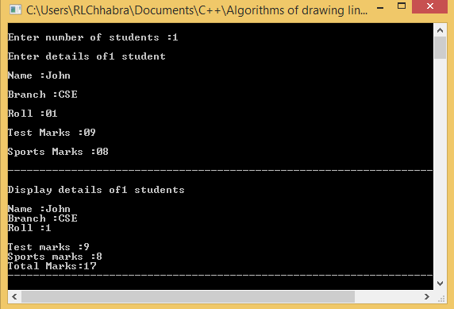

Experiment-10.a

Date-03-Oct-2018

**Aim:** To write a program to demonstrate example of hierarchical inheritance in c++.

**Algorithm:**

1: Starts.

2: Define a base class as information with variables name , e_id , roll , salary , fee.

3: Make a derived class of information as student.

4: Define member functions of student as get_data() and display1().

5: Make a derived class of information as employee.

6: Define member functions of employee as get_edata() , display2().

7: Definition of main function.

8: Declare objects of class student and employee.

9: Call classes member functions with help of their respective objects.

10: Stop.

**Program:**

#include<iostream>

#include<conio.h>

#include<stdlib.h>

using namespace std ;

class information

{ protected: string name ; int e_id ; int roll ; float salary , fee ; };

class student: public information

{ public: void get_sdata()

{ cout<<"Enter details of student"<<endl;

cout<<"\nName :"; fflush(stdin);

getline(cin , name);

cout<<"\nRoll :" ; cin>>roll ;

cout<<"\nFee :" ; cin>>fee ; }

void display1()

{cout<<"-----------------------------------------------------"<<endl;

cout<<"\nDisplay detais of student"<<endl;

cout<<"\nName :"<<name ;

cout<<"\nRoll :"<<roll ;

cout<<"\nFee :"<<fee<<endl ;

cout<<"-----------------------------------------------------"<<endl;}};

class employee: public information

{ public: void get_edata()

{ cout<<"Enter details of employee"<<endl;

cout<<"\nName :"; fflush(stdin);

getline(cin, name);

cout<<"\nID :"; cin>>e_id ;

cout<<"\nSalary :" ; cin>>salary ; }

void display2()

{ cout<<"----------------------------------------------------"<<endl;

cout<<"\nDisplay details of employee"<<endl;

cout<<"\nName :"<<name ;

cout<<"\nID :"<<e_id ;

cout<<"\nSalary :"<<salary<<endl ;

cout<<"-----------------------------------------------------"<<endl; }};

int main()

{ student s_obj ; employee e_obj ;

s_obj.get_sdata() ; s_obj.display1() ;

e_obj.get_edata() ; e_obj.display2() ;

getch() ; return 0 ; };

**Input Given:** student -> name = “Jemes” , roll = 01 , fee = 10,000.

Employee -> name = “Bob”, roll= 02, salary = 50,000.

**Output:**

